Strategic Plan
  - East Tennessee Chapter (2025 - 2027)
03/20/25

INTRODUCTION 3
GLOSSARY 4
MANAGEMENT BOARD AND STAFF 9
VISION 10
MISSION 10
SWOT ANALYSIS 10
Strengths 10
Weaknesses 10
Opportunities 11
Threats 11
OBJECTIVES 12
STRATEGIES 13
Key Strategies 13
Strategic Action Programs 13
TACTICS 14
EVALUATION 15
Formative Evaluation 15
Summative Evaluation 15

GLOSSARY

Term | Definition
Formative Evaluation | Formative Evaluation shows what has, or has not been completed to date. This type of evaluation can be undertaken at regular intervals as a form of developmental review.  Frequency/Criteria/Target  How often, and against which criteria, for whom, and with respect to which, if any, goals and policies will the initial evaluation occur? Will there be an initial evaluation only, or a schedule of periodic evaluations?  Goals/Objectives  What goals and objectives, as defined in this strategic plan, are progressing, and how well is the team achieving the goals at the point of evaluation?  Information Usage  What will you do with the information you gather during the formative evaluation?  Move Forward Assessment  What now needs to be done, what has to happen in the future, and what should you desist from doing at this stage?  Alignment  To what extent does your progress so far align with the vision, mission and values espoused in the strategic plan?  Note: Some chapters choose to insert a copy of a scorecard they create and maintain to validate their 3-year vision is being met instead of writing out the above detail. Example below:  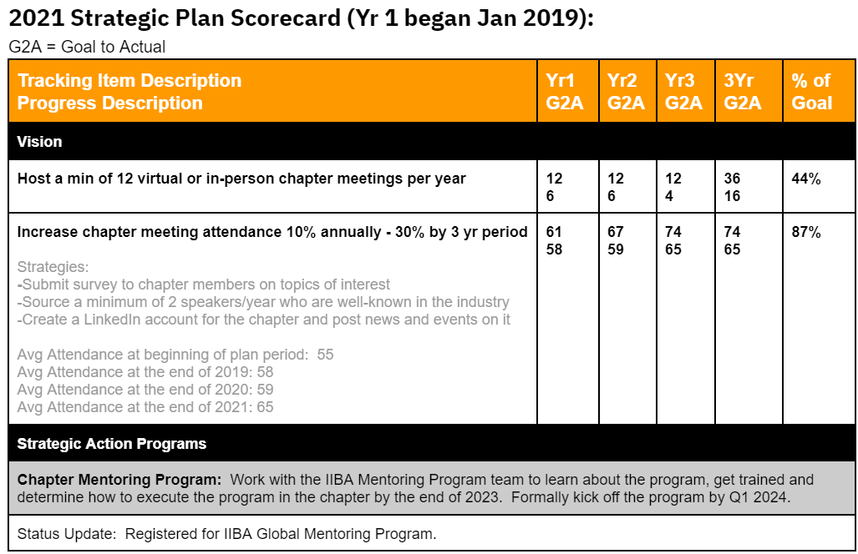  Hansen, Jens J. "Woodhill Park Retreat." Two Templates for the Not-for-profit Sector: Strategic Planning for Dummies and an Evaluation Research Template. Woodhill Park Retreat, 2008. Web. 18 Dec. 2015.
Mission | Mission is the series of steps that guide a business to carrying out its vision. To change old and outdated ways of operating, missions must be adopted from the board of directors down to each chapter member.
Objectives | Objectives define whether a mission has been accomplished, usually quantified in the form of key performance indicators (KPIs). To maximize the chances of meeting certain objectives, chapters can adopt the SMART goal attainment strategy.
Priority Scale (H,M,L) | Priority Meaning Description  H - High Must have Describes an item the chapter must do to be considered a success based on the chapter’s vision for the future  M - Medium Should have Represents an item that should be included in annual business plans but could be added in later years or be satisfied in other ways if necessary  L - Low Nice to have Describes an item which is considered desirable but not necessary. This will be included if time and resources permit.
Strategies | As objectives guide missions, so too do strategies guide objectives. If the goal of a taxi company was to increase revenue by $10 million annually, a potential strategy may include expanding the service into five new cities by the end of the year.
Strategic Action Programs | Larger programs the organization might create with defined leadership and goals to to support one or more objectives, i.e. Chapter Mentoring Program, Sponsorship Program, Certification Program, Business Analysis Development Day Program, etc. The need for the program is typically defined in the Strategic Plan, but the supporting tactics will be defined by the program team once it’s established within the Strategic Plan period.
Summative Evaluation | Summative Evaluation shows what has, or has not, been achieved insofar as the strategic plan is concerned.  Frequency/Criteria/Target  How often, and against which criteria, for whom, and with respect to which, if any, goals and policies will the final evaluation occur?  Reporting Evaluation  To what extent has your operational plan and the various annual reports prepared addressed the strategic plan?  Data Management  How can the data gathered when completing the summative evaluation be used for informing the next cycle of strategic planning?  Final Assessment and Management  How valid are the tenets the team has operated under for the duration of the strategic plan? Do they still apply, and if not, why should they be revised?  Note: Some chapters choose to insert a copy of a scorecard they create and maintain to validate their 3-year vision is being met instead of writing out the above detail. Example below:    Hansen, Jens J. "Woodhill Park Retreat." Two Templates for the Not-for-profit Sector: Strategic Planning for Dummies and an Evaluation Research Template. Woodhill Park Retreat, 2008. Web. 18 Dec. 2015.
SWOT Analysis | SWOT (strengths, weaknesses, opportunities, and threats) analysis is a framework used to evaluate a company's competitive position and to develop strategic planning. SWOT analysis assesses internal and external factors, as well as current and future potential.  A SWOT analysis is designed to facilitate a realistic, fact-based, data-driven look at the strengths and weaknesses of an organization, initiatives, or within its industry. The organization needs to keep the analysis accurate by avoiding preconceived beliefs or gray areas and instead focusing on real-life contexts. Chapters should use it as a guide and not necessarily as a prescription.  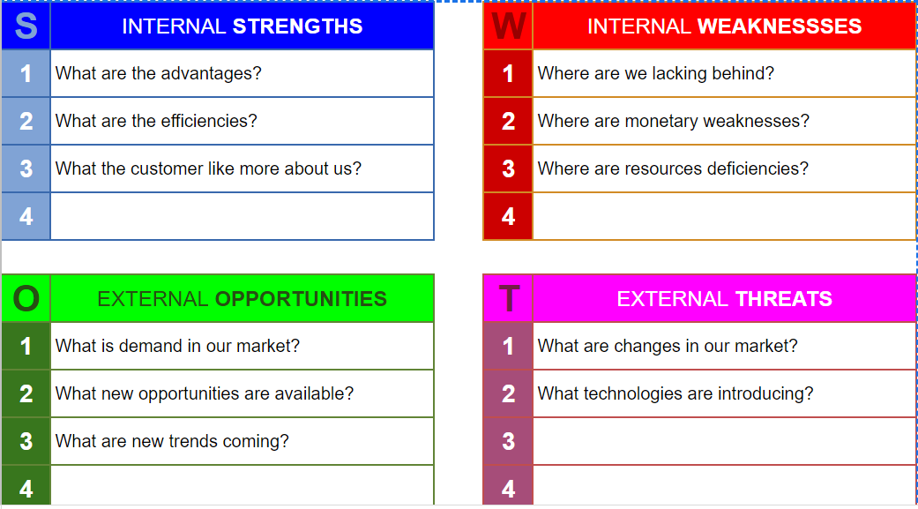  https://www.investopedia.com/terms/s/swot.asp  We chose SWOT for this template, but there are other popular methods chapters can use to understand their organizational environment if they choose to. Some include:  - PESTLE (political, economic, social, technological, legal and environmental) analysis  - Scenario Planning  - Critical success factor analysis  - Porter's Five Forces framework  https://www.nibusinessinfo.co.uk/content/swot-pestle-and-other-models-strategic-analysis#:~:text=These%20include%3A,scenario%20planning
Tactics | Tactics encompass the specific, low-level actions that are taken for strategies to be fulfilled.
Vision | Vision encompasses ideas that summarize where a chapter sees itself in the future. Where will it operate? Which target audience will it serve? How will it position itself against the competition? What does the chapter want to be known for? The answers to these questions should inspire and challenge the chapter to do better without being completely unattainable.
VMOST | The strategic method used to create the Strategic Plan template. The VMOST Analysis is a tool that allows a business to evaluate its core strategies in terms of whether the supporting activities of that strategy are being carried out. The VMOST analysis tries to answer that by looking at five core elements: vision, mission, objectives, strategies, and tactics.  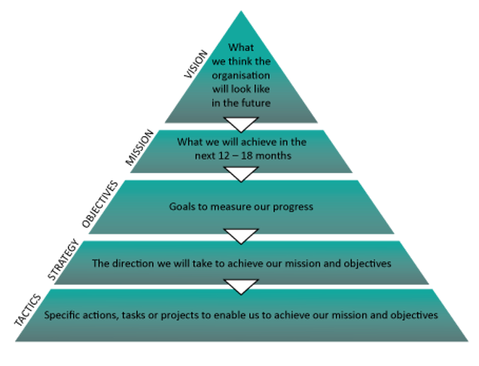  https://brendanbroadhead.wixsite.com/vmost/what-is-vmost  https://fourweekmba.com/vmost-analysis/

MANAGEMENT BOARD AND STAFF
- Jordan Eisenback - President
- Warren Green - VP Marketing
- Jessica Lear - Treasurer
- Sheri Smith - VP Professional Development
- Olivia Marcum - VP Events
- Heather McGlinchy - VP Operations
- Deedee Chism - VP Sponsorship

VISION

The vision for the East Tennessee chapter is to be the trusted hub for business analysis excellence—empowering professionals to connect, grow, and lead change within their careers and communities.

MISSION
The mission for the East Tennessee chapter is to make business analysis accessible to all by fostering a collaborative environment where members can develop practical skills, build strong professional connections, and contribute to a dynamic community of practitioners.

SWOT ANALYSIS
This section addresses the key strengths, weaknesses, threats and opportunities for the East Tennessee chapter that could or does affect the team’s ability to fulfill its vision and mission.

Strengths
Internal Strengths
Passionate and diverse board
Focus on inclusion and accessibility
Energy and innovation from younger leadership

Weaknesses
Internal Weaknesses | Mitigation
Scattered regional membership | Hybrid/virtual-first programming model
Limited funding base | Build sponsorships aligned with local economic development priorities
Limited member engagement | Targeted outreach, quarterly surveys, visible recognition, and tailored programming
Limited certification among members | Build sponsorships aligned with local economic development priorities
New/inexperienced board | Documented workflows and strong team collaboration

Opportunities
External Opportunities
Workforce development initiatives (city grants, chamber partnerships)
Engaging young professionals (18–37)
Creating alternative learning paths
Access to IIBA global resources and branding

Threats
External Threats | Mitigation
Competing priorities for member time and attention | Focused, engaging, hybrid programming; clear member value messaging
Reliance on volunteer time and capacity | Documented workflows, onboarding, shared tools
Lack of awareness among potential members | Consistent branding, outreach campaigns, partnerships

OBJECTIVES
The below shows which objectives should be met in order to fulfill the vision and mission of the East Tennessee chapter as well as attend to any targeted SWOT items the chapter would like to address as part of the Strategic Plan.

ID | Objective (O) | Focus Areas | KPIs
O1 | Increase engagement and membership | Membership Engagement | # active members, # new members
O2 | Improve certification readiness and success rates among chapter members | Professional Development | % of members participating in study groups or cert prep; # new certifications
O3 | Build and formalize strategic partnerships with academic and workforce organizations | Partnerships & Outreach | # of exploratory meetings or collaborative activities
O4 | Establish financial sustainability through sponsorships and grants | Sponsorship & Funding | $ in sponsorship revenue; # of new sponsors
O5 | Strengthen operational infrastructure and communications across the board | Governance & Operations | Completion of documented processes
O6 | Highlight the relevance of analysis across diverse job titles and industries | Membership Engagement | Number of themed events or content pieces featuring varied roles
O7 | Increase access to BA career development for underrepresented communities | Professional Development | % of programming inclusive of underrepresented groups
O8 | Build employer and city alliances to support local talent retention | Partnerships & Outreach | # of exploratory meetings or collaborative activities

STRATEGIES
The following critical strategies will be pursued by the East Tennessee chapter which we feel will allow us to reach our chapter’s vision at the end of the term of this strategic plan:

Key Strategies
Map each strategy to one or more Objectives that the strategy contributes to in the Traceability field next to each strategy.

ID | Strategy (S) | Priority  (H,M,L) | Traceability
S1 | Launch inclusive, skills-focused community events | H | O1, O6
S2 | Facilitate peer-led study groups and curate new and existing training materials | H | O2
S3 | Coordinate with academic institutions and workforce agencies to co-design programs that support shared regional talent goals | M | O3, O7
S4 | Develop and deploy sponsorship package targeting local stakeholders | H | O4, O7
S5 | Build and document board operations and communications workflows | M | O5, O9
S6 | Design and implement tiered programming for professionals at all career stages | H | O1, O2
S7 | Create a long-term digital infrastructure plan (tools, governance, content) | M | O5
S8 | Promote access and representation through targeted programs and outreach | M | O6, O7

TACTICS
Map each tactic to one or more Strategies that the tactic contributes to in the Traceability field next to each tactic.

ID | Tactic (T) | Traceability
T1 | Distribute recurring member surveys to assess interests and needs | S1, S2
T2 | Audit and curate existing training content from past sessions | S2
T3 | Develop and pilot modular certification prep curriculum based on curated content, aligned to IIBA competency model. | S2, S6
T4 | Launch pilot study group using new materials and collect participant feedback. | S2
T5 | Host pilot webinar featuring analysts and diverse industry roles | S1, S6
T6 | Gather post-session feedback to refine topics, format, and speaker selection for future events. | S1
T7 | Launch a monthly newsletter series themed around IIBA competencies, featuring content and upcoming events to foster continuous learning and engagement | S1, S2, S6
T8 | Launch "Member Spotlight" features in newsletters and social posts | S1, S8
T9 | Launch “Certification Journey” features in newsletters and social posts | S2
T10 | Analyze newsletter and social metrics and feedback to improve engagement | S1, S2, S6
T11 | Share relevant job postings in newsletters and social posts | S3
T12 | Publish event calendar and promote in newsletters and social posts | S1
T13 | Establish shared tools and basic governance for board operations, communications, and content management | S5, S7
T14 | Finalize and share sponsorship package with potential partners | S4
T15 | Connect with local universities and employers for internship alignment | S3
T16 | Explore shared priorities and partnership opportunities with regional economic and workforce development organizations like Knoxville Chamber of Commerce and American Job Center | S3, S4, S8
T17 | Host mock interviews and resume reviews with volunteer mentors | S1, S2
T18 | Explore program alignment and potential collaboration opportunities with regional youth programs like 865 Academies | S3, S8
T19 | Pilot mentorship program with volunteer senior level professionals
T20 | Develop and maintain a board knowledge base with role-specific documentation, onboarding guides, and key decisions | S5

EVALUATION
The following evaluation methods will show how the Program’s evaluation will be completed.

Formative Evaluation
The section describes the East Tennessee chapter’s evaluation method and/or process it will use to perform a formative evaluation on how the chapter is progressing toward their strategic plan objectives to date.
The East Tennessee chapter will perform it’s formative evaluation in the following manner:
- Use mid-year surveys and annual member feedback to assess engagement, satisfaction, and value.
- Evaluate the status of objectives across all focus areas and adjust tactics as needed.
- Share updates during chapter meetings and newsletters to maintain transparency and accountability.
- Leverage findings to prioritize high-impact actions and discontinue low-performing initiatives.

Summative Evaluation
The section describes the East Tennessee chapter’s evaluation method and/or process it will use to perform a summative evaluation on how the chapter is progressing toward their strategic plan objectives at the end of the 3 year period.
The East Tennessee chapter will perform its formative evaluation in the following manner:

Complete a comprehensive review of strategic goals and KPIs at the end of each quarter, year, and the strategic cycle (Q4 2027).

Assess alignment of annual reports, financial outcomes, and operational decisions with the strategic objectives.

Use membership analytics, event outcomes, and sponsorship performance to inform long-term decisions.

Review the ongoing relevance of the chapter’s mission, vision, and strategic assumptions.

Apply insights to guide the next strategic planning cycle and ensure continuity of successful programs.

